**Practical 1.2**

**AIM: Preparing Raspberry Pi: Hardware preparation and installation**

**What is RaspberryPi OS?**

* Raspberry Pi OS formerly known as Raspbianos the recommended operating system for normal use on a Raspberry Pi.
* Raspberry Pi OS is a free operating system based on Debian, optimised for the Raspberry Pi hardware. Raspberry Pi OS comes with over 35,000 packages: precompiled software bundled in a nice format for easy installation on your Raspberry Pi.
* Raspberry Pi OS is a community project under active development, with an emphasis on improving the stability and performance of as many Debian packages as possible.
* The Raspberry Pi is an incredible device, but it won’t do much of anything without an operating system. Luckily, choosing and installing an appropriate operating system on your Raspberry Pi has never been easier. One simple method is to use **NOOBS**, or **“New Out of Box Software**.”

**What is NOOBS?**

* NOOBS is an easy operating system installer which contains Raspberry Pi OS and LibreELEC.
* It also provides a selection of alternative operating systems which are then downloaded from the internet and installed.

**What you’ll need to install NOOBS on the Raspberry Pi**

* Besides your Raspberry Pi and essential peripherals, here’s all you’ll need.
* A computer with an SD card slot
* An SD or microSD card of at least 8 GB

**Step 1:Download NOOBS and extract it**

* The NOOBS download page will let you choose between NOOBS and “NOOBS Lite.”
* NOOBS includes a full version of Raspbian, so you can install that particular operating system without using the internet at all.
* With NOOBS Lite, on the other hand, you’ll need a network connection to install any of the operating systems NOOBS makes available – even Raspbian.
* 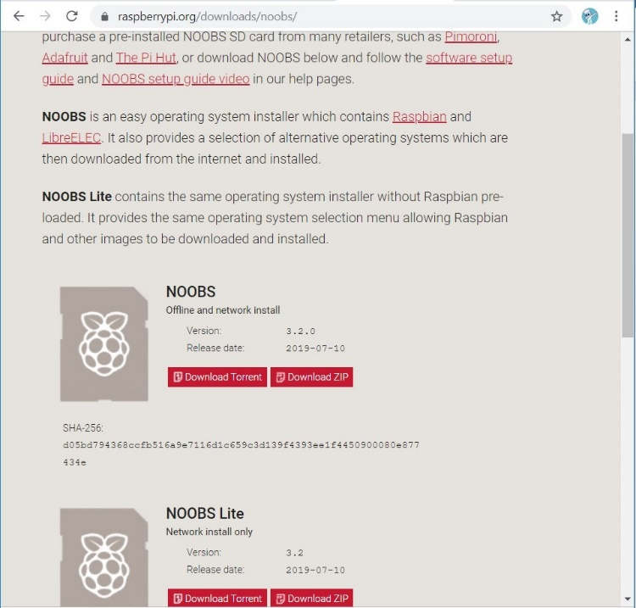

**Step 2: Format the SD card**

* You’re going to want to format it as FAT. There are a few ways to do this:
* On Mac or Windows, use the [**SD Association’s Formatting Tool**](https://www.sdcard.org/downloads/formatter_4/eula_windows/) . Make sure the **“Format size adjustment”** option is set to “**on**.” Then erase it in FAT (or MS-DOS) format.

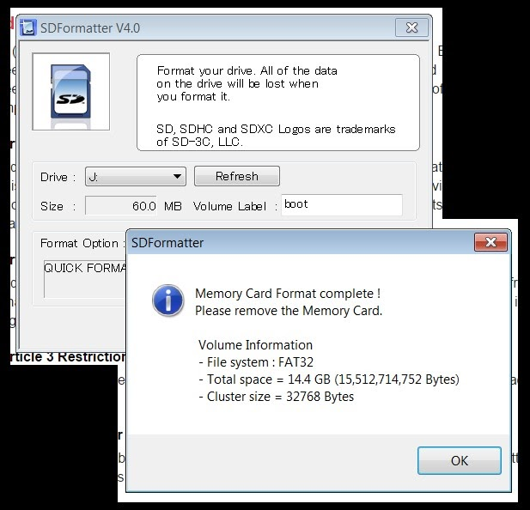

**Step 3: Put the NOOBS files on the SD card**

* Now, just drag and drop the NOOBS files into your newly formatted SD card.

**Step 4: Put your SD card into your Raspberry Pi and boot it up**

* Once you have NOOBS on your SD card, using it is incredibly easy. Just put the SD card into your Raspberry Pi and start that sucker up.

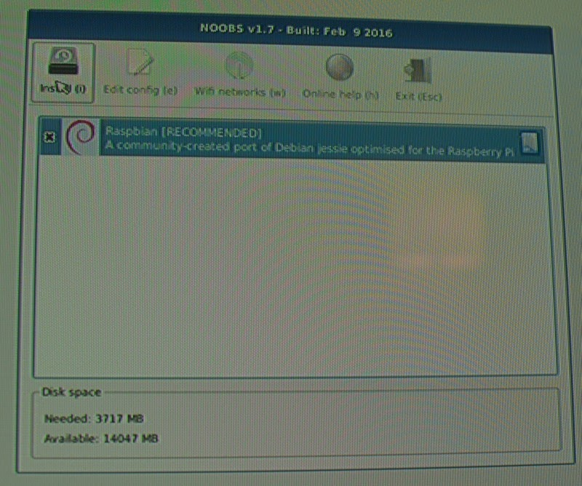

* After booting to NOOBS, you’ll be greeted with a menu that will let you choose which operating system you’d like to install on your Pi.
* You should check the box for **Raspbian**, and then click **Install**
* Click **Yes**at the warning dialog, and then sit back and relax. It will take a while, but Raspbian will install.

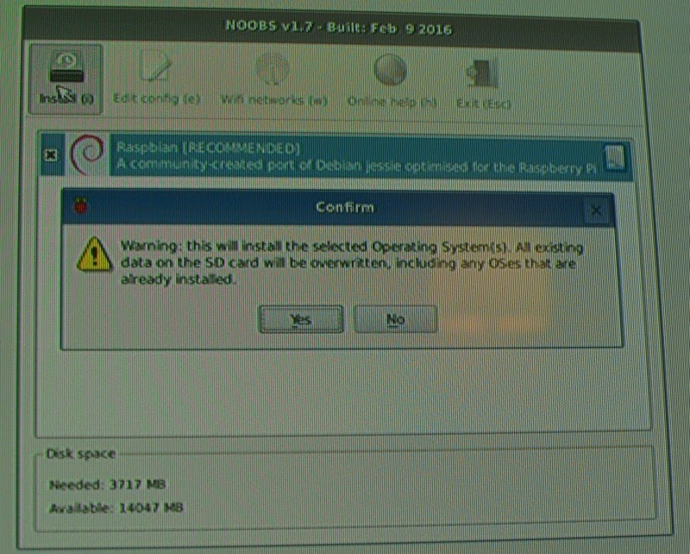

* When Raspbian has been installed, click **OK**and your Raspberry Pi will restart and Raspbian will then boot up.

